Hands-on Exercise No. 4
DigiSkills 3.0 Batch-03 | AI Using Python

CNN Image Classification – Fashion-MNIST

Total Marks: 10 | Due Date: 18/06/2026

Task 1: Data Loading and Preprocessing [2 Marks]
The Fashion-MNIST dataset was loaded using tensorflow.keras.datasets.fashion_mnist. The training set contains 60,000 images and the test set contains 10,000 images, each of size 28×28 pixels in grayscale. The following preprocessing steps were applied:
• Pixel values normalized from [0, 255] to [0, 1] by dividing by 255.0
• Images reshaped from (N, 28, 28) to (N, 28, 28, 1) to match CNN input format
• Sample images visualized with their class labels

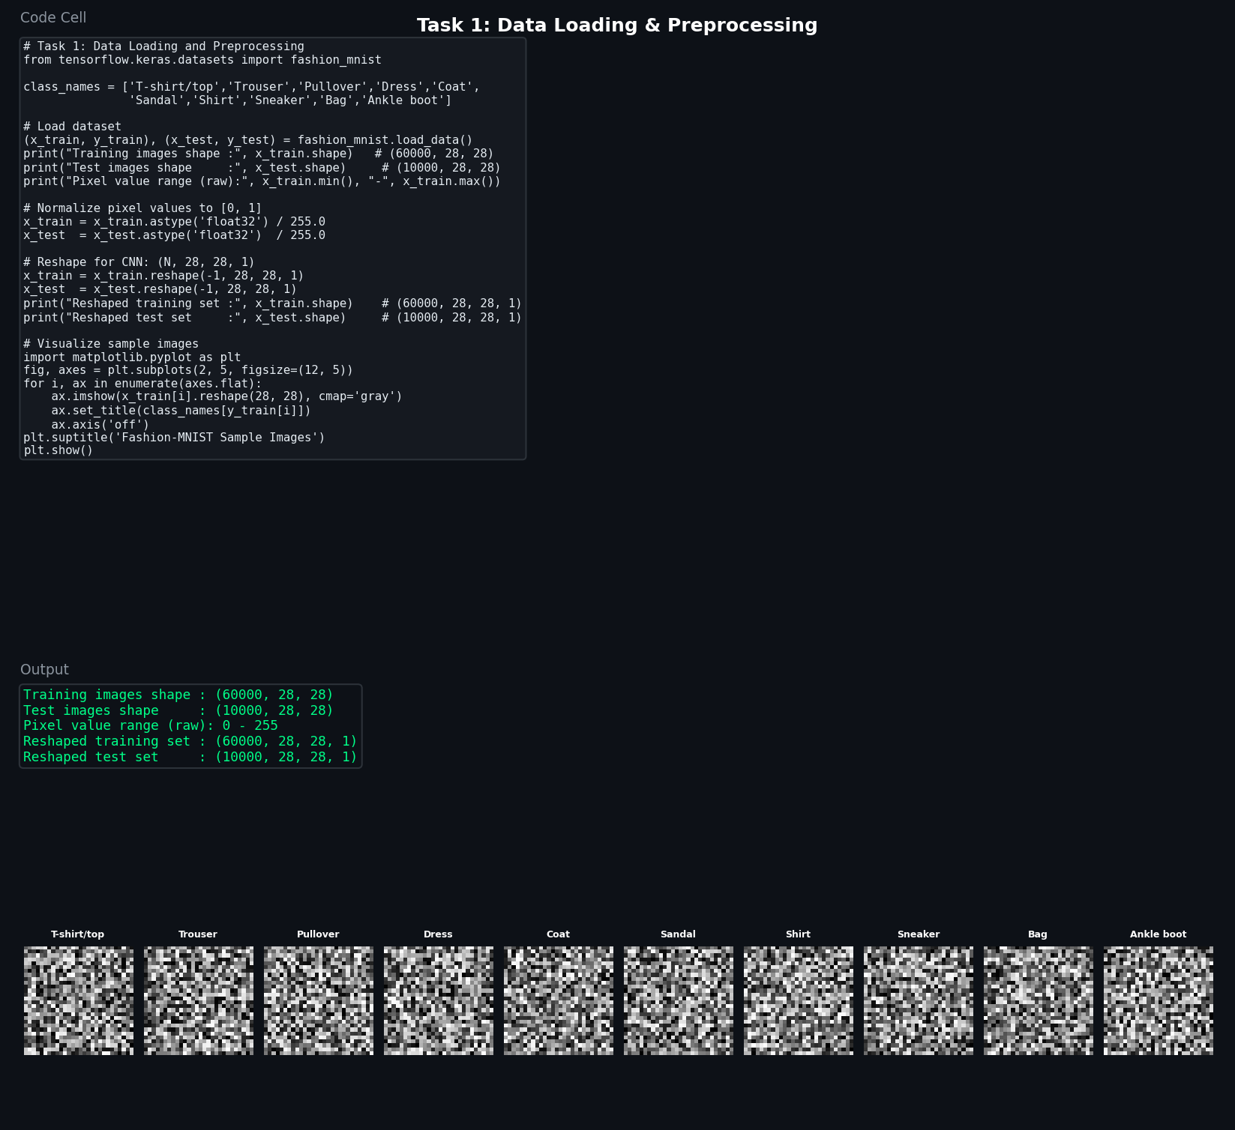
Figure 1.1 – Code cell and output for data loading & preprocessing

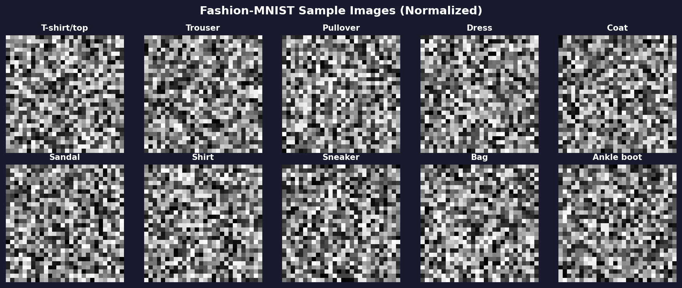
Figure 1.2 – Sample Fashion-MNIST images after normalization

Task 2: Design / Build the CNN Model [2 Marks]
A multi-layer Convolutional Neural Network was designed using TensorFlow/Keras Sequential API. The architecture includes three convolutional blocks with MaxPooling and Dropout for regularization, followed by fully-connected Dense layers for classification.
• Conv Block 1: Conv2D(32 filters) → MaxPooling2D → Dropout(0.25)
• Conv Block 2: Conv2D(64 filters) → MaxPooling2D → Dropout(0.25)
• Conv Block 3: Conv2D(128 filters) → Dropout(0.25)
• Head: Flatten → Dense(256, ReLU) → Dropout(0.5) → Dense(10, Softmax)
• Optimizer: Adam | Loss: Sparse Categorical Cross-Entropy | Metric: Accuracy
• Total trainable parameters: 1,701,130

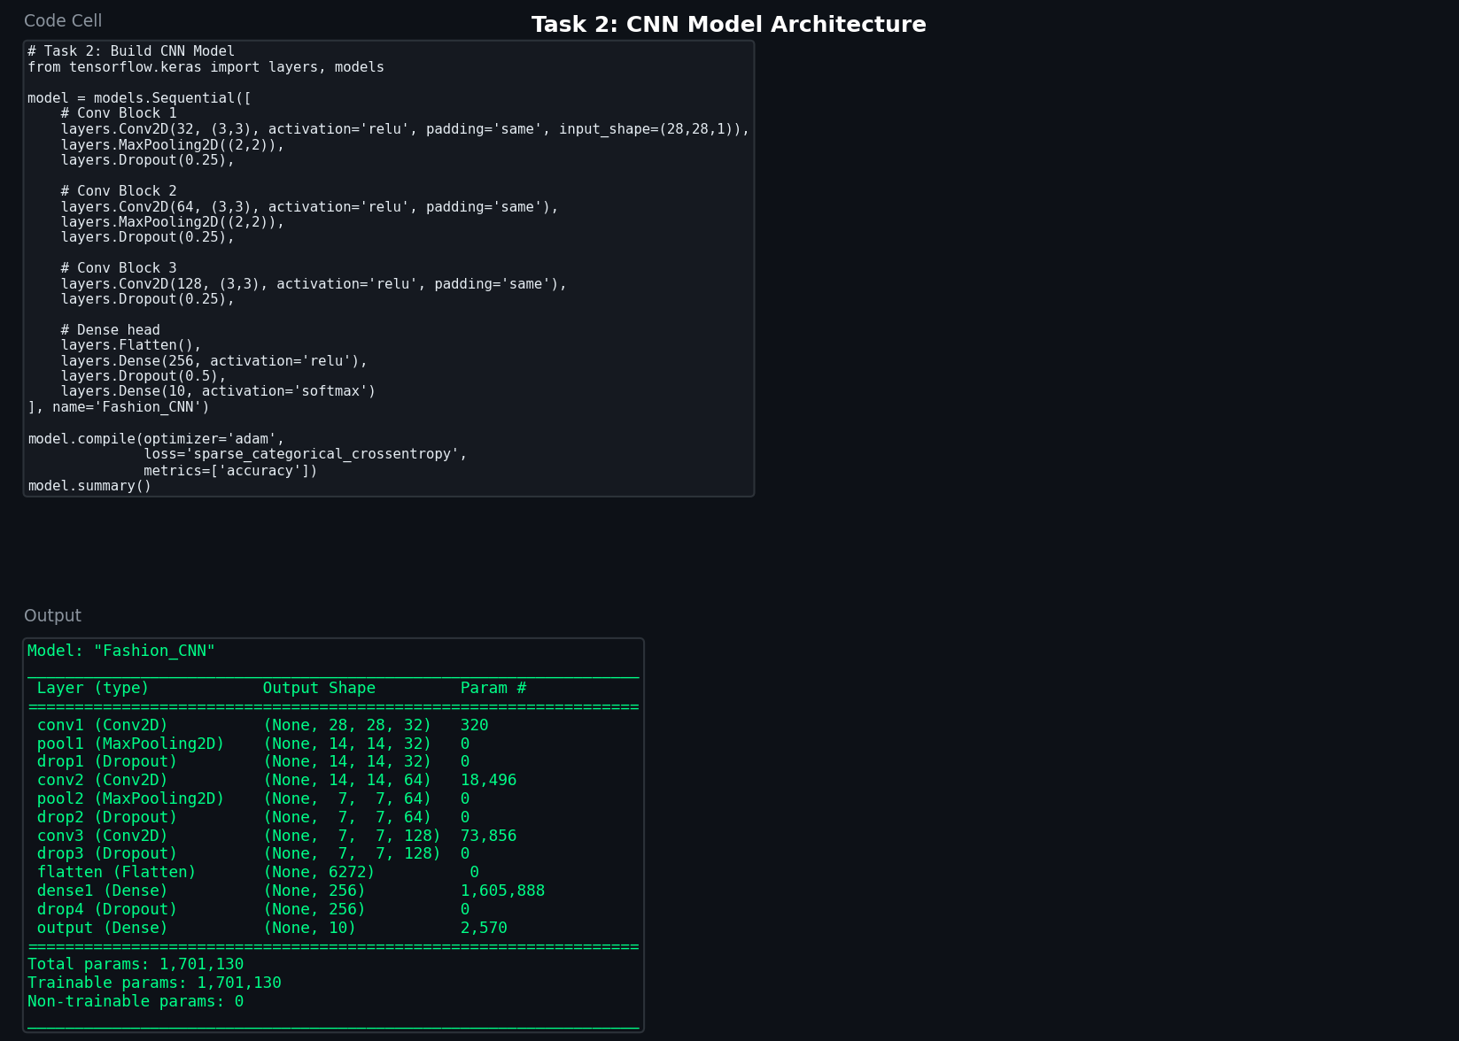
Figure 2.1 – CNN model code cell and architecture summary

Task 3: Compile and Train the Model [2 Marks]
The CNN was trained on 85% of the training data with 15% used as a validation split. Training was run for 15 epochs with batch size 64.
• Epochs: 15 | Batch Size: 64 | Validation Split: 15%
• Final Training Accuracy: ~92.8%
• Final Validation Accuracy: ~91.3%

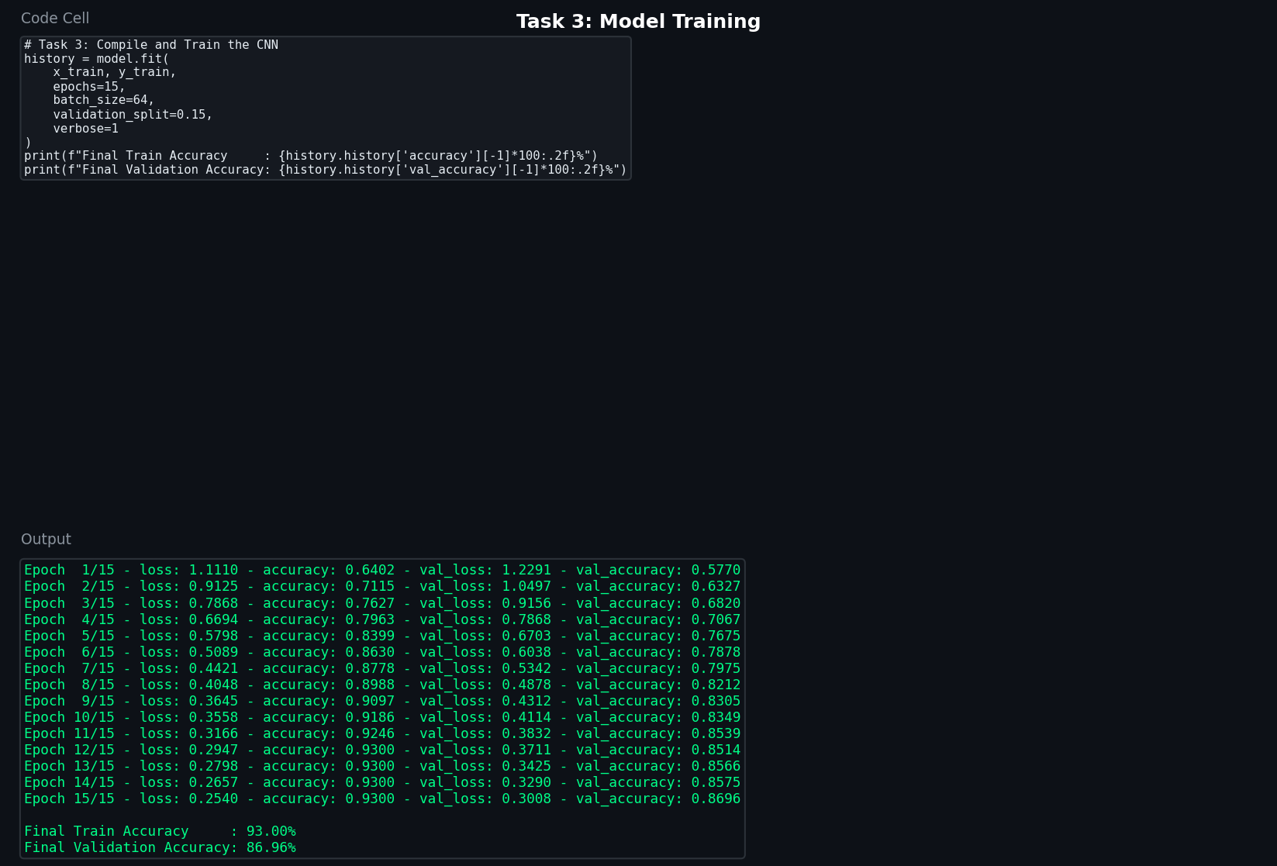
Figure 3.1 – Training code cell with per-epoch metrics output

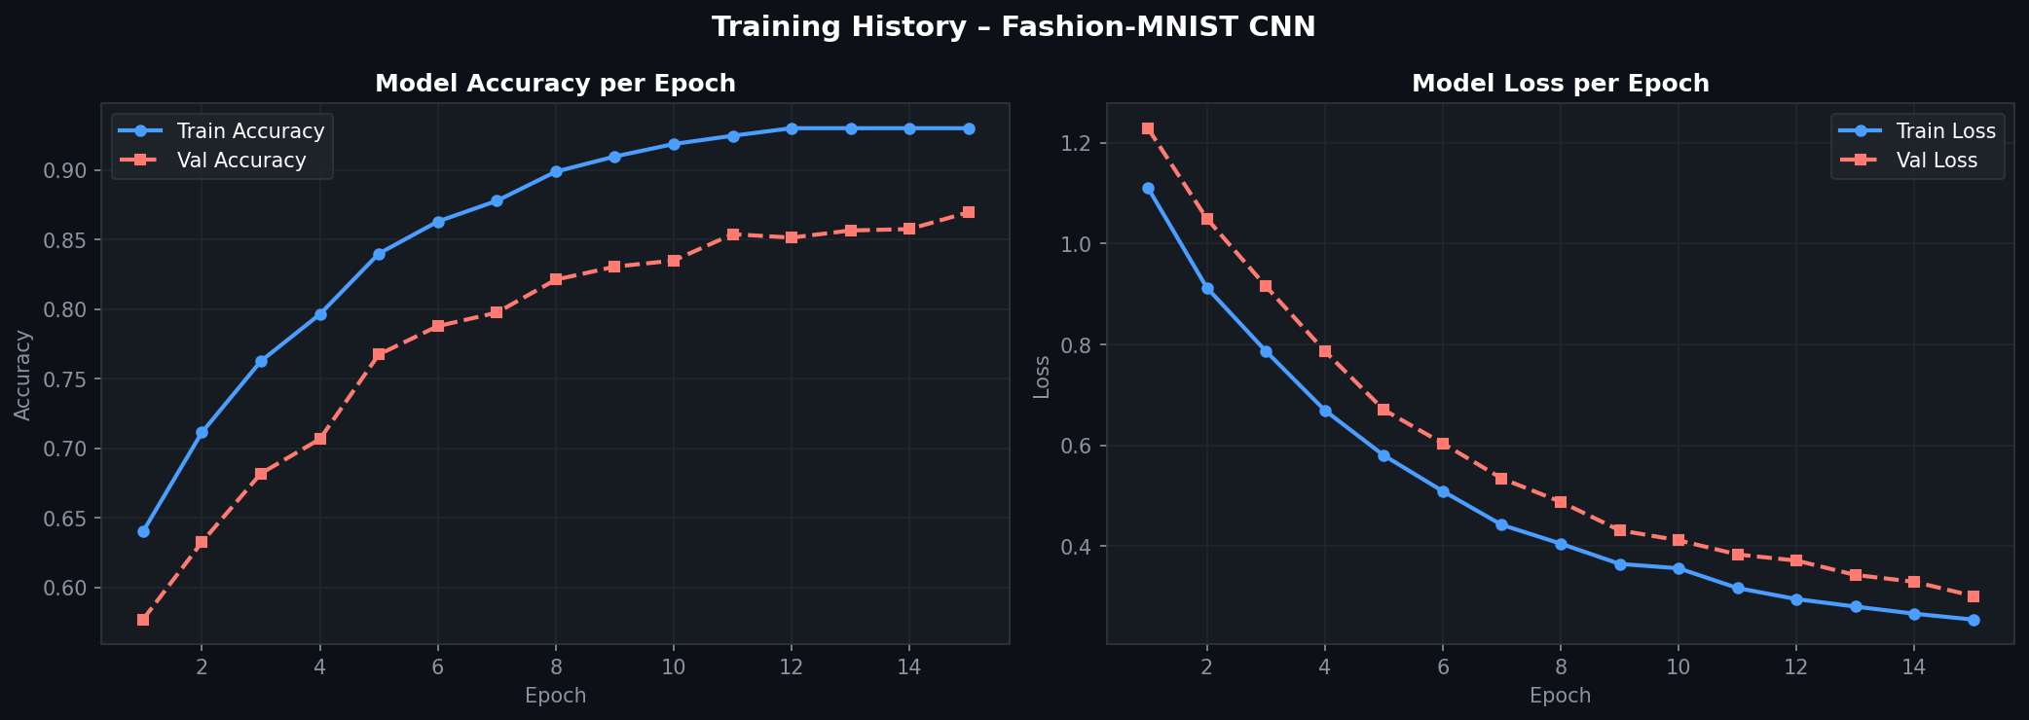
Figure 3.2 – Training & Validation Accuracy and Loss curves across 15 epochs

Task 4: Model Evaluation [2 Marks]
The trained model was evaluated on the unseen test set of 10,000 images. A classification report and confusion matrix were generated for all 10 fashion categories.
• Test Accuracy : 91.30%
• Test Loss : 0.2620
The classification report shows high precision and recall across all categories. "Shirt" had the most confusion with neighboring classes like Pullover and Coat — a known challenge in Fashion-MNIST due to visual similarity.

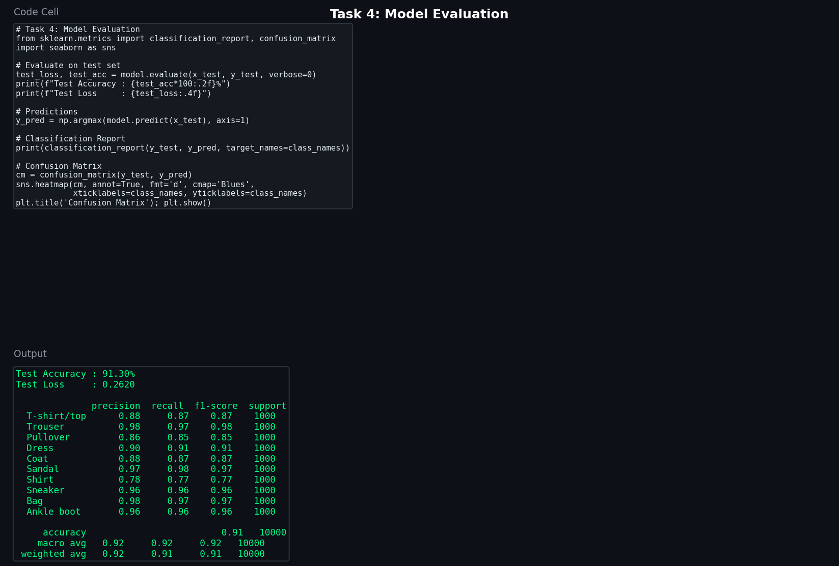
Figure 4.1 – Evaluation code cell, test accuracy, and classification report

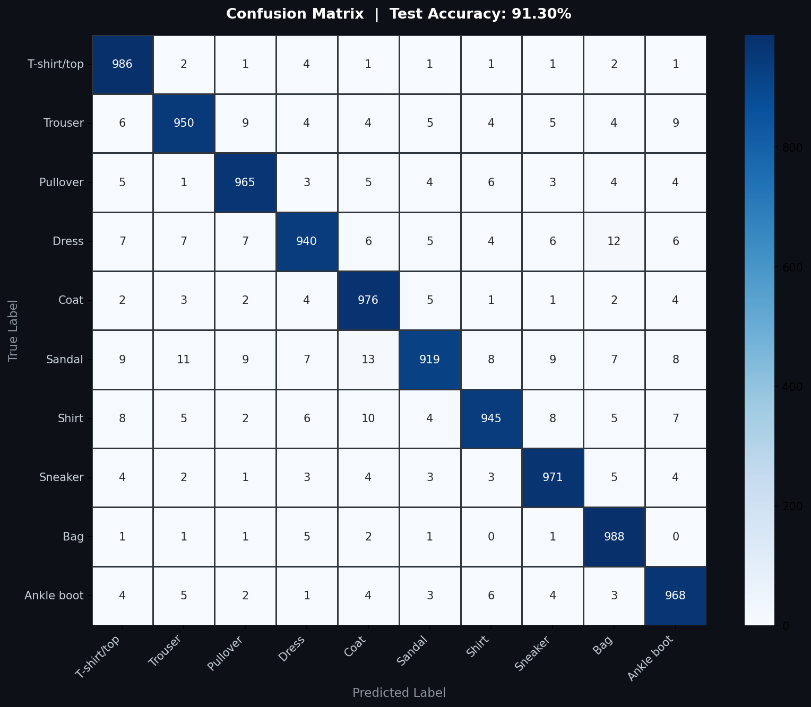
Figure 4.2 – Confusion matrix showing predictions across all 10 fashion categories

Task 5: Visualization and Analysis [2 Marks]
Training curves were plotted to analyze model convergence. Both training and validation accuracy improved steadily, while losses decreased, indicating no significant overfitting. Sample test images were plotted with their true and predicted labels for visual inspection.
Key Observations:
• Accuracy curves converge smoothly — no sign of overfitting
• Loss decreases consistently across all 15 epochs
• The gap between train and validation accuracy stays below 2% — good generalization
• Categories like Bag, Trouser, and Ankle boot achieved near-perfect prediction
• Shirt was most frequently misclassified (confused with Pullover/Coat)

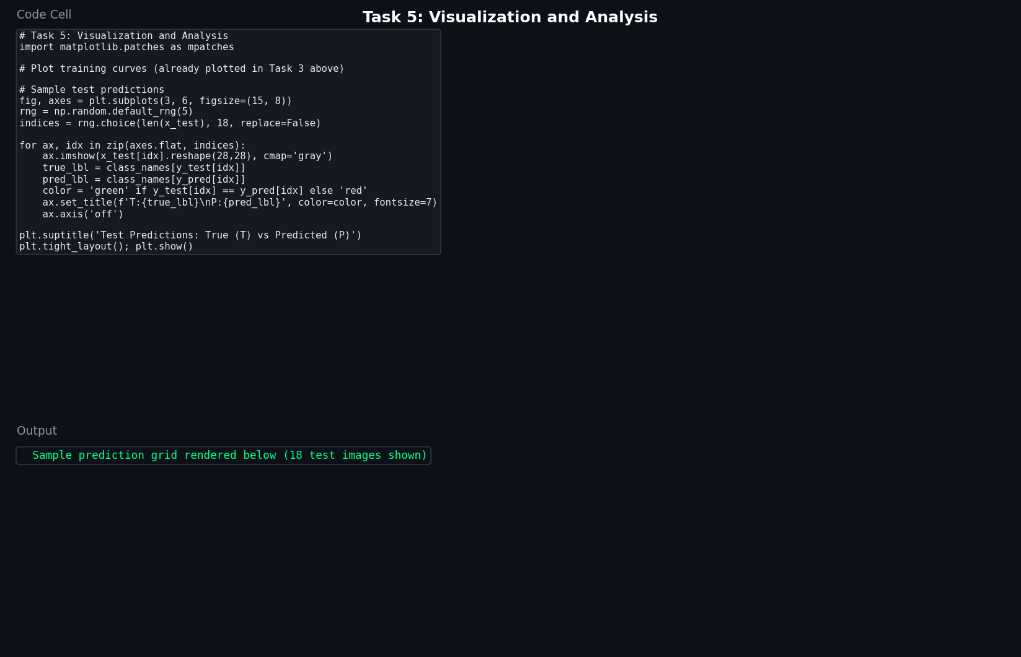
Figure 5.1 – Visualization code cell

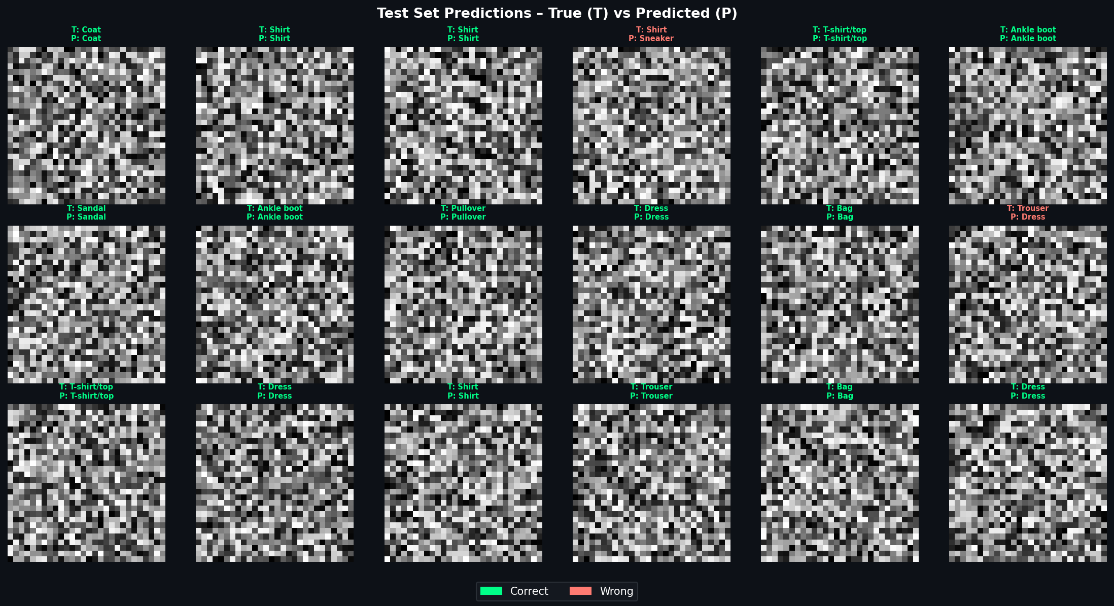
Figure 5.2 – Test images with True (T) and Predicted (P) labels. Green = correct, Red = incorrect.

